HASTINGS & 1066 CALENDAR for 2014
£5 + £1.50 P&P

Hastings is twinned with the village of Hastings in Sierra Leone, West Africa. The Hastings Sierra Leone Friendship Link has produced a beautiful calendar of pictures of Hastings & 1066 Country, with the help of the East Sussex Arts Club.
They’re full of beautiful images of Hastings and 1066 Country – they make a lovely present to give to friends and family. They only cost £5 + £1.50 p&p, and because the Friendship Link is run entirely by volunteers, all of the profit from the calendars will go towards supplying medicines and equipment for the Health Centre in the village.

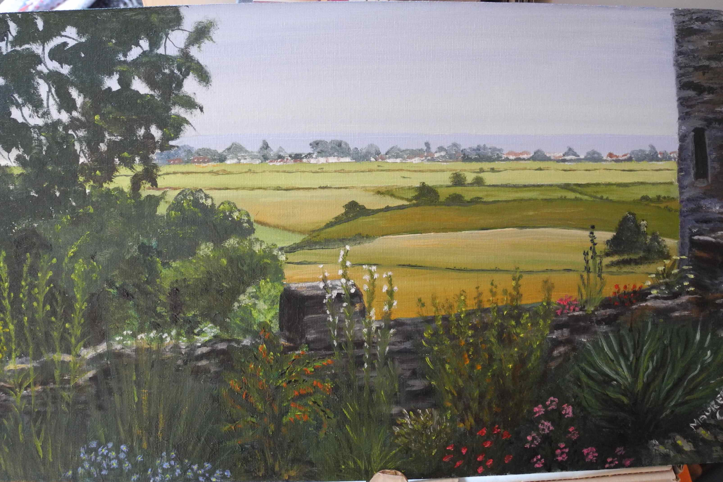
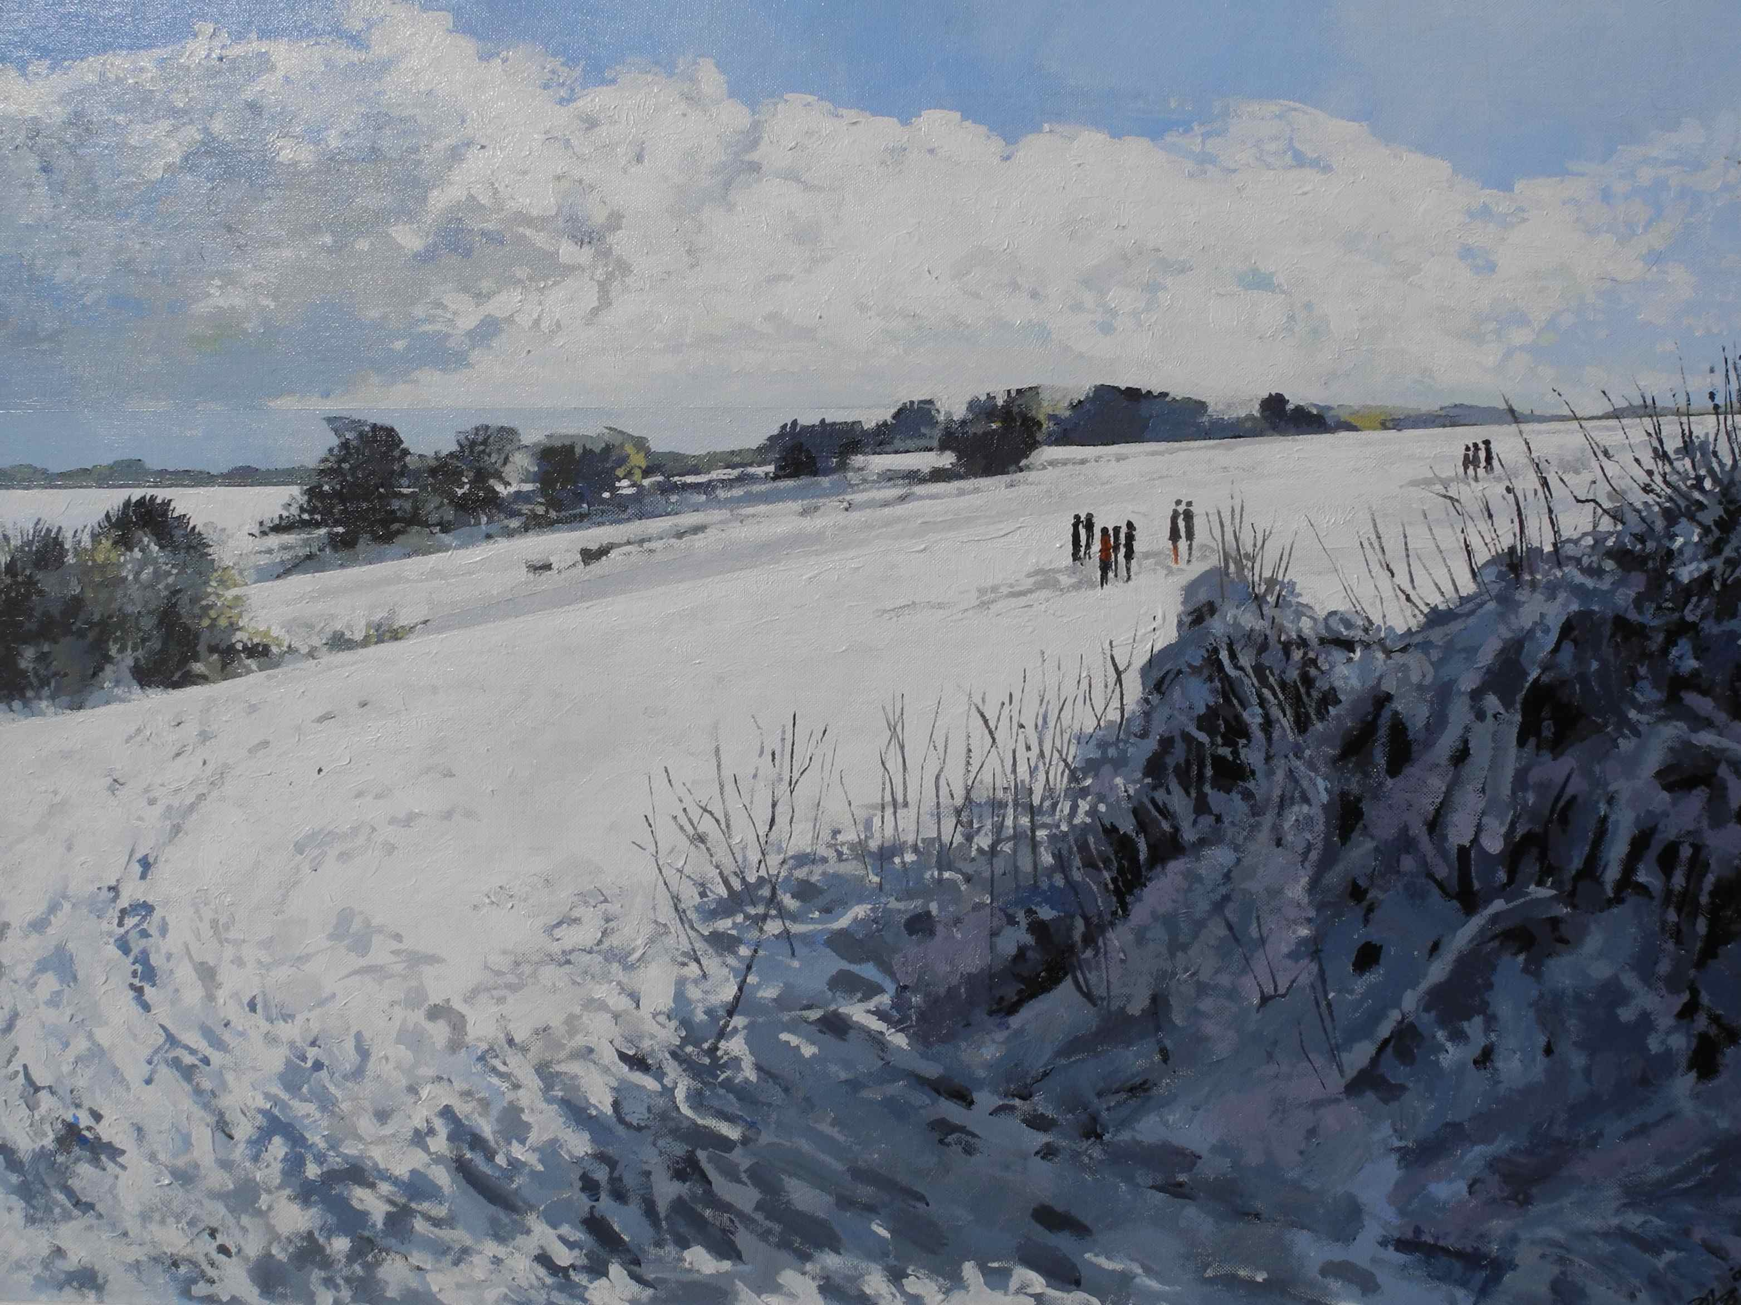
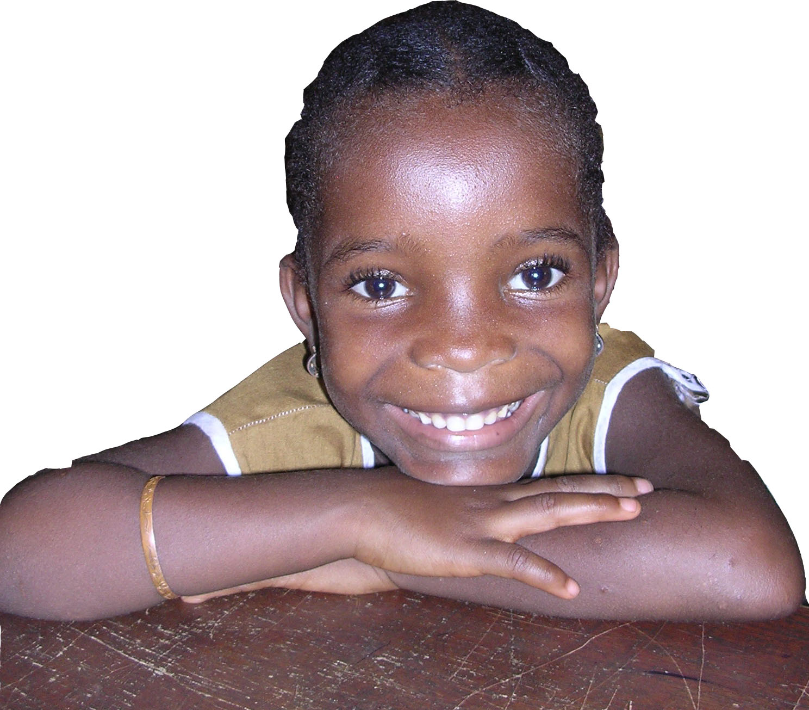

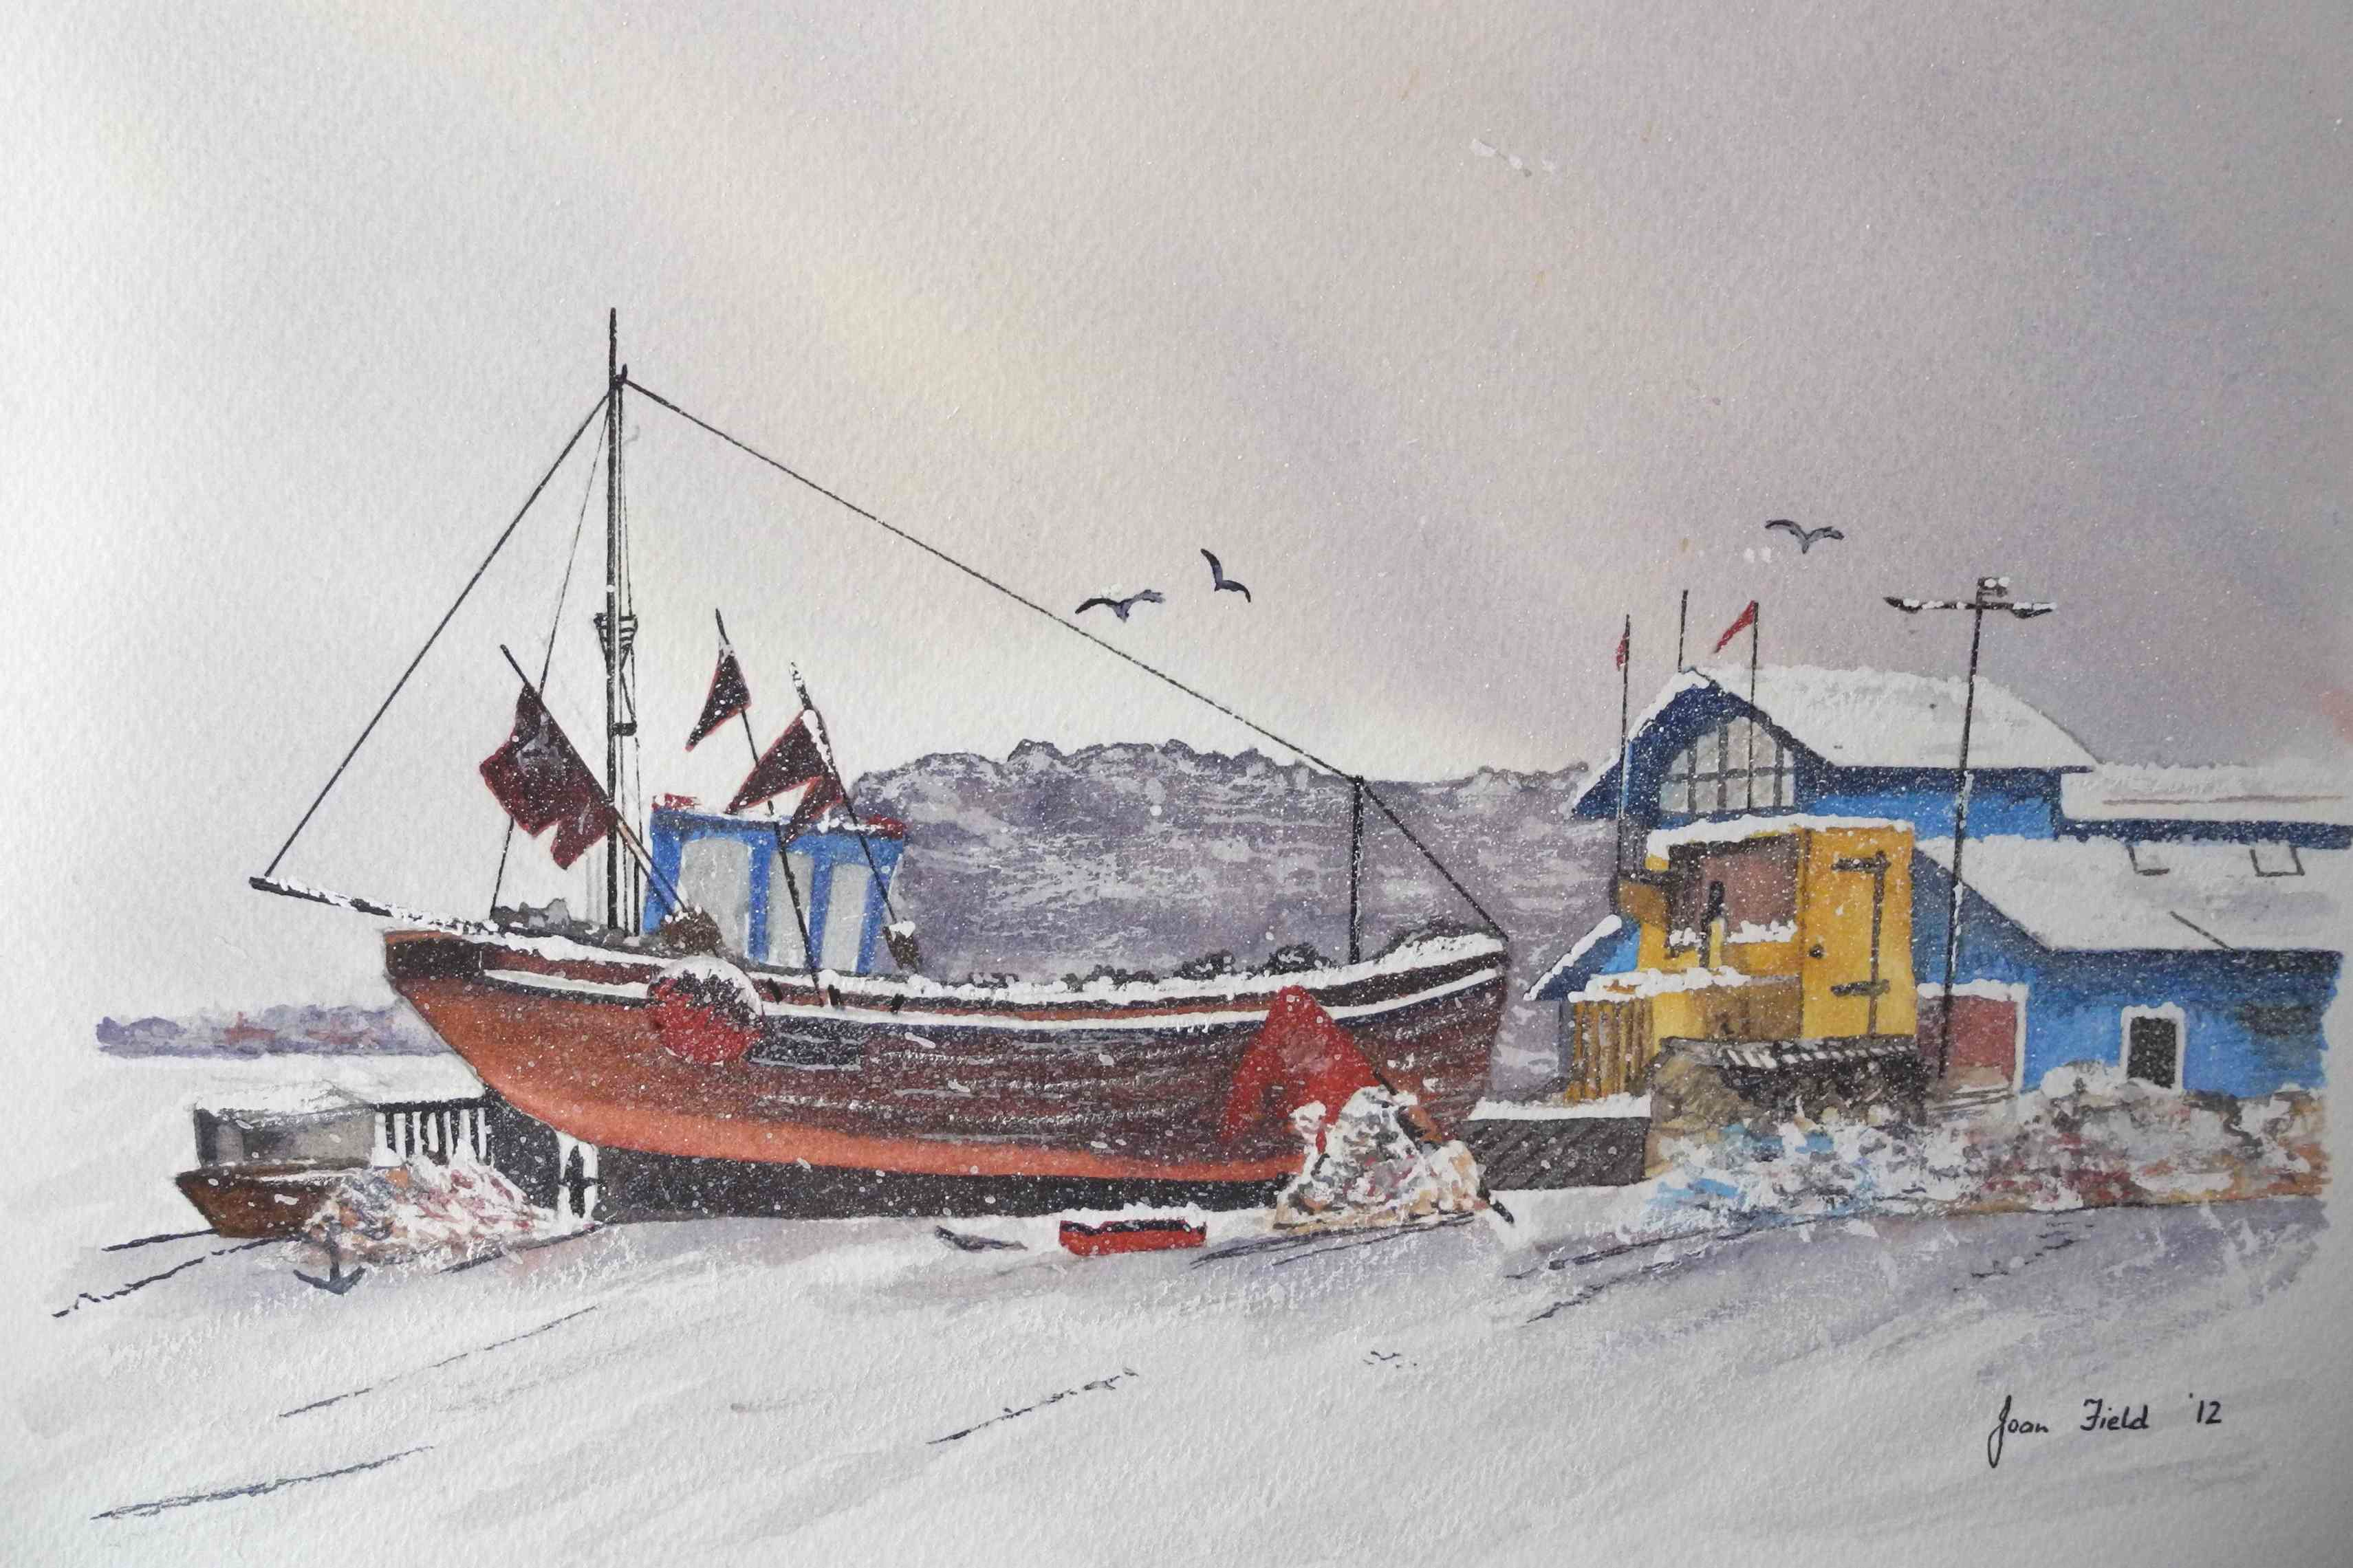
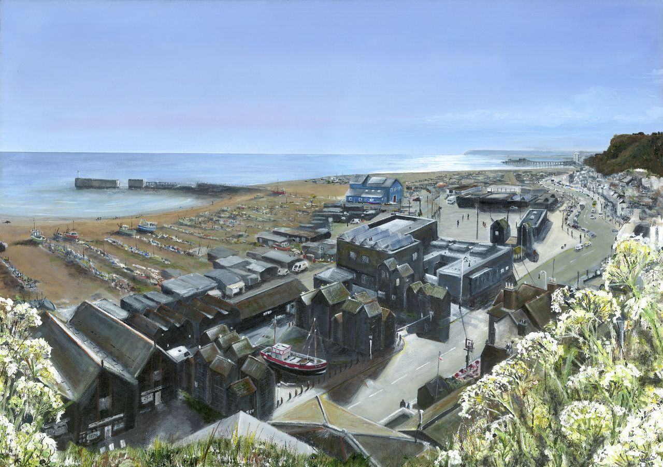

Sierra Leone has one of the highest rates of infant death in the world. Thanks to the generosity of residents and visitors here in Hastings UK, and those who love Hastings, we are making a big difference to the lives of the people of Hastings Sierra Leone, especially the children, and the mothers and their babies.
Thank you for your support!

