10th Twinning Anniversary Concert
Friday 26 May 2017, 7.15pm
Raising funds for the Link’s Education Projects in
Hastings, Sierra Leone
Featuring
SUSSEX BRASS
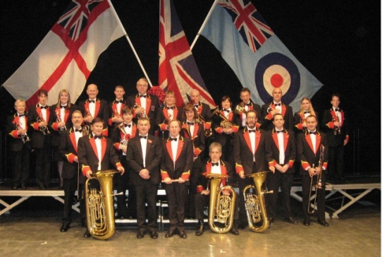
St Matthews Church,
St Matthews Road,
St Leonards, TN38 0TN

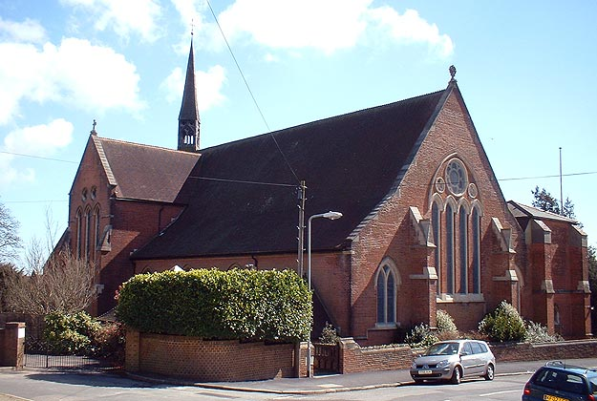
Tickets £10 (Students £5) Contact 01424 436603, or on the door on the night!
Includes refreshments!

